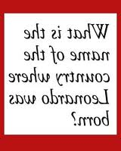
News Bite
Leonardo da Vinci
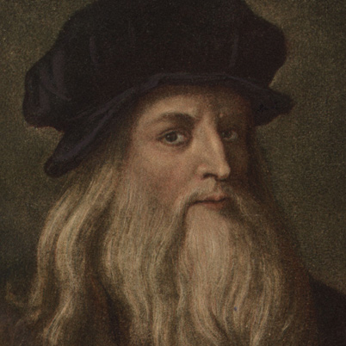
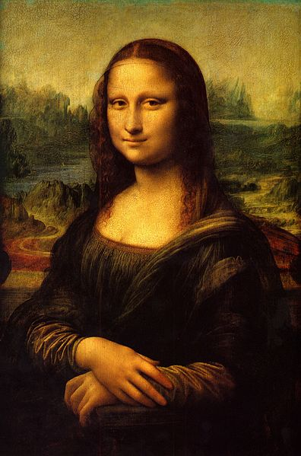

Leonardo da Vinci was born on 15 April 1452 in Italy. Da Vinci was an artist and an inventor and a very creative person.
Da Vinci painted many pictures, but his most famous picture is in a museum in Paris, France. The picture above of the lady with her arms folded is called the ‘Mona Lisa’. The painting is said to be priceless.
In August 1911, over one hundred years ago, the Mona Lisa was stolen from the Louvre Museum. It was found two years later and returned.

Did you know?
Leonardo da Vinci wrote backwards to stop people stealing his ideas.

Questions
- Where was da Vinci born?
- What is da Vinci’s most famous painting called?
- What do you think ‘priceless’ means?
- What happened in August 1911?
- Write two proper nouns from the text.

News Bite
Leonardo da Vinci

Leonardo da Vinci was born on 15 April 1452 in Italy. Da Vinci was an artist and an inventor and a very creative person.
Da Vinci painted many pictures, but his most famous picture is in a museum in Paris, France. The picture above of the lady with her arms folded is called the ‘Mona Lisa’. The painting is said to be priceless.
In August 1911, over one hundred years ago, the Mona Lisa was stolen from the Louvre Museum. It was found two years later and returned.

Did you know?
Leonardo da Vinci wrote backwards to stop people stealing his ideas.

Questions
- Where was da Vinci born?
- What is da Vinci’s most famous painting called?
- What do you think ‘priceless’ means?
- What happened in August 1911?

News Bite
Leonardo da Vinci

Leonardo da Vinci was born on 15 April 1452 in Italy. Da Vinci was an artist and an inventor and a very creative person.
Da Vinci painted many pictures, but his most famous picture is in a museum in Paris, France. The picture above of the lady with her arms folded is called the ‘Mona Lisa’. The painting is said to be priceless.

Did you know?
Leonardo da Vinci wrote backwards to stop people stealing his ideas.

Questions
- What is da Vinci’s most famous painting called?
- What do you think ‘priceless’ means?
- What happened in August 1911?

News Bite
Leonardo da Vinci

Leonardo da Vinci was born on 15 April 1452 in Italy. Da Vinci was an artist and an inventor and a very creative person.
The picture above of the lady with her arms folded is called the ‘Mona Lisa’. The painting is said to be priceless.

Did you know?
Leonardo da Vinci wrote backwards to stop people stealing his ideas.

Questions
- What is da Vinci’s most famous painting called?
- What happened in August 1911?

