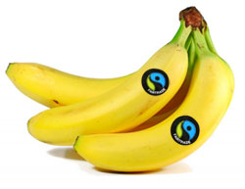
News Bite

Have you ever seen this logo when you're buying food?

The symbol means that what you are buying is from a producer who takes part in 'fair trade'. Fair trade is a scheme which helps farmers who produce the things you buy get a fair price for their crops.

This may seem obvious, but lots of people in poorer countries have to sell their goods at prices so low that they can’t earn enough money to live on.

Often only a tiny bit of the money you pay for something goes to the person who actually made it. The rest goes to pay for transport or packaging or advertising.
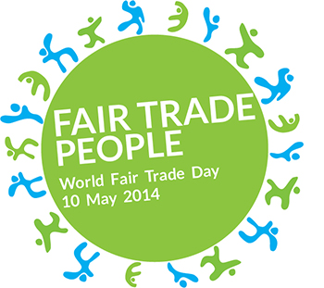
World fair trade day is on the 10th May 2014.

Questions
- What is this news bite about?
- Who does the fair trade scheme help?
- What does fair trade mean?
- How does fair trade help people in poorer countries?
- What does most of the money that we pay for something go towards?
- What date is ‘World Fair Trade Day’ this year?

